Academic Pulse Forum SDD| BSSE Group 9

ACADEMIC PULSE FORUM

SOFTWARE DESIGN DOCUMENT

Version: v1.0
GitHub repository:
Date: June 24th, 2026 Coordinator: Ms. Mary Nsabagwa Supervisor: Mr. Lule Emmanuel
Project: Academic Pulse Forum – Recess Project 2026,
Group: G-9

NAME | REG NO | STUDENT NO
ALORO GILBERT | 24/U/03273/EVE | 2400703273
AYIKO BILL CLINTON | 25/U/26527/EVE | 2500726527
AHEEBWAMUKAMA MAGIN | 25/U/04156/EVE | 2500704156
WANYANA BERNADETTE | 25/U/04344/EVE | 2500704344
KATUSIIME MONICA | 25/U/04223/EVE | 2500704223

TABLE OF CONTENTS
- INTRODUCTION 5
  - Purpose 5
  - Scope 5
  - Overview 5
  - Reference material 5
  - Definitions and acronyms 6
- SYSTEM OVERVIEW 7
  - Product perspective 7
  - Assumptions 7
  - Constraints 7
  - Design goals and principles 7
- SYSTEM ARCHITECTURE 8
  - Architectural design 8
    - Deployment and hosting operations 9
    - Security 9
    - API design specifications 10
  - Decomposition description 10
    - Context diagram (DFD level 0) 10
    - Level - 1 Data flow diagram 12
    - Sequence – online/offline messaging and sync 13
    - Sequence – quiz lifecycle 14
    - Activity – inactivity, warnings and auto-blacklist 15
    - Class diagram 16
    - Use case model 17
  - Design rationale 18
- DATA DESIGN 19
  - Data description 19
  - Data dictionary 19
- COMPONENT DESIGN 22
  - Offline Synchronization Design 22
  - Quiz and Proctoring Design 22
  - Machine learning 23
- HUMAN INTERFACE DESIGN 24
  - Overview of user interface 24
  - Screen images 24
  - Screen objects and actions 28
- REQUIREMENTS MATRIX 30

TABLE OF FIGURES
Figure 1 – Academic Pulse Forum: System Architecture 8

Figure 2 - Deployment diagram 9

Figure 3 - Context diagram (DFD level 0) 11

Figure 4 - Level 1 DFD 12

Figure 5 - Sequence diagram (Online/Offline message sync) 13

Figure 6 - Sequence diagram (Quiz lifecycle) 14

Figure 7 - Activity diagram 15

Figure 8 - Class diagram 16

Figure 9 - Use case diagram 17

Figure 10 - Entity Relationship Diagram (ERD) 19

Figure 11 - For Indexing strategy 21

Figure 12 – Registration page 24

Figure 13 - Login page 25

Figure 14 - Lecturer dashboard 26

Figure 15 - Member/Student dashboard 26

Figure 16 - Admin dashboard 27

Figure 17 - Mockup screen 27

LIST OF TABLES
Table 1 - Definitions & Acronyms 6
Table 2 - Design goals & principles 7
Table 3 - API paths 10
Table 4 - Use case actors & responsibilities 17
Table 5 - User table 20
Table 6 - Message table 20
Table 7 - Message Exclusion table 20
Table 8 - Warning & Blacklist table 20
Table 9 - Quiz table 21
Table 10 - Functional requirements 30

INTRODUCTION

Purpose
This System Design Document (SDD) describes the architecture and detailed design of the Smart Discussion Forum, a platform that lets an academic discussion group hold organized, well-moderated conversations across a Laravel web application and a Java desktop application. The document translates the project requirements into a concrete software design — architecture, data, behavior, interfaces and deployment — so that the development team can implement, test, and present a consistent system.

Scope
The Smart Discussion Forum supports topic-based discussions with real-time chat, content moderation, selective (excluded-recipient) messaging, automatic answer notifications, per- topic PDF export, an inactivity warning and auto-blacklist regime, rules-based onboarding, participation marking, time-boxed proctored quizzes, per-group statistics, machine- learning topic classification and recommendation, and forwarding of posts to social media. Two interfaces are delivered: a Laravel web client for online use, and a Java desktop client that additionally works offline and synchronizes when connectivity returns.

Overview
This document is organized into eight segments to logically organize and aid the systematic guidance of the reader through it.
- Section 1 [Introduction]: Defines the nature of the background of the Smart Discussion Forum, the scope of the document and the system’s operation definitions to the reader.
- Section 2 [System Overview]: Summarizes the system functions, user contexts and requirements.
- Section 3 [System Architecture]: Server Tier design, object-oriented designs, database drivers, and specific engineering rationales based on the architectural design.
- Section 4 [Data Design]: This section habours system's information domain into data structures and provides a complete data dictionary of objects.
- Section 5 [Component Design]: Defines duties of class components through mappings.
- Section 6 [Human Interface Design]: Shows the user experience with the system via screens, visuals and interface layouts.
- Section 7 [Requirements Matrix]: software components and data structures directly back core system requirements.
- Section 8 [Appendices]: All supplementary references for the system design.

Reference material
- Smart Discussion Forum — Recess Assignment brief (2026).
- Laravel, Laravel Reverb, Sanctum and Horizon documentation.

- OpenJFX (JavaFX) documentation; SQLite documentation

Definitions and acronyms
Term | Meaning
SDD | System Design Document
SPA | Single-Page Application (the Livewire/Vue web front end)
REST API | Stateless HTTP interface consumed by the Java client and web front end
WebSocket / WSS | Persistent, bidirectional channel used for real-time chat (Laravel Reverb)
Sanctum | Laravel token-based API authentication for the desktop client
Outbox | Local queue of messages composed offline, awaiting sync
Blacklist | Temporary, time-boxed suspension of an inactive member
Kiosk / proctor mode | Locked quiz interface that prevents other actions during an attempt
ML | Machine Learning (topic classification and recommendation)
DFD / ERD | Data Flow Diagram / Entity Relationship Diagram
Table 1 - Definitions & Acronyms

SYSTEM OVERVIEW

Product perspective
The system is a new, self-contained product structured as a three-tier client–server application with a separate machine-learning microservice. The Laravel backend is the single source of truth; the web and desktop clients are thin presentation layers over a shared REST API and a shared real-time channel. The desktop client adds a local store so members can keep reading and composing while offline, in the spirit of mobile chat applications such as WhatsApp.

Assumptions
- Each member has a unique, valid e-mail address used for notifications and account recovery.
- The backend, database, cache and ML service are reachable over the network when a client is online.
- Desktop clients have local storage available for the offline cache and outbox.
- Social-media forwarding depends on the availability of the chosen platform's sharing API.

Constraints
- The web interface must be built with the Laravel framework; the desktop interface must be a Java GUI.
- The draft SDD is submitted on MUELE by 25th June 2026; code lives in a private Git repository to which all members contribute.
- Hosting should target a free tier (bonus marks), which bounds memory, CPU and worker counts.
- Quizzes must lock the interface and enforce server-side timing; latecomers receive no extra time.

Design goals and principles
Goal | How the design addresses it
Separation of concerns | Thin clients; business rules centralized in Laravel; ML isolated as a microservice.
Offline resilience | Desktop local SQLite + outbox + idempotent delta-sync keyed on a client- generated UUID.
Real-time experience | Laravel Reverb WebSocket broadcasting with presence channels.
Fairness & integrity | Server-authoritative quiz timing, kiosk lock, and auto-submit on expiry.
Maintainability | Eloquent domain models, queued jobs, scheduled tasks, and clear REST contracts.
Portability | Stateless API and externalized cache/queue so the app can run on a free host.
Table 2 - Design goals & principles

SYSTEM ARCHITECTURE
The system uses a three-tier architecture — presentation, application and data — augmented by a dedicated machine-learning microservice and external integrations. The Laravel backend exposes both a REST API (for the web front end and the Java desktop client) and a WebSocket service for real-time messaging.
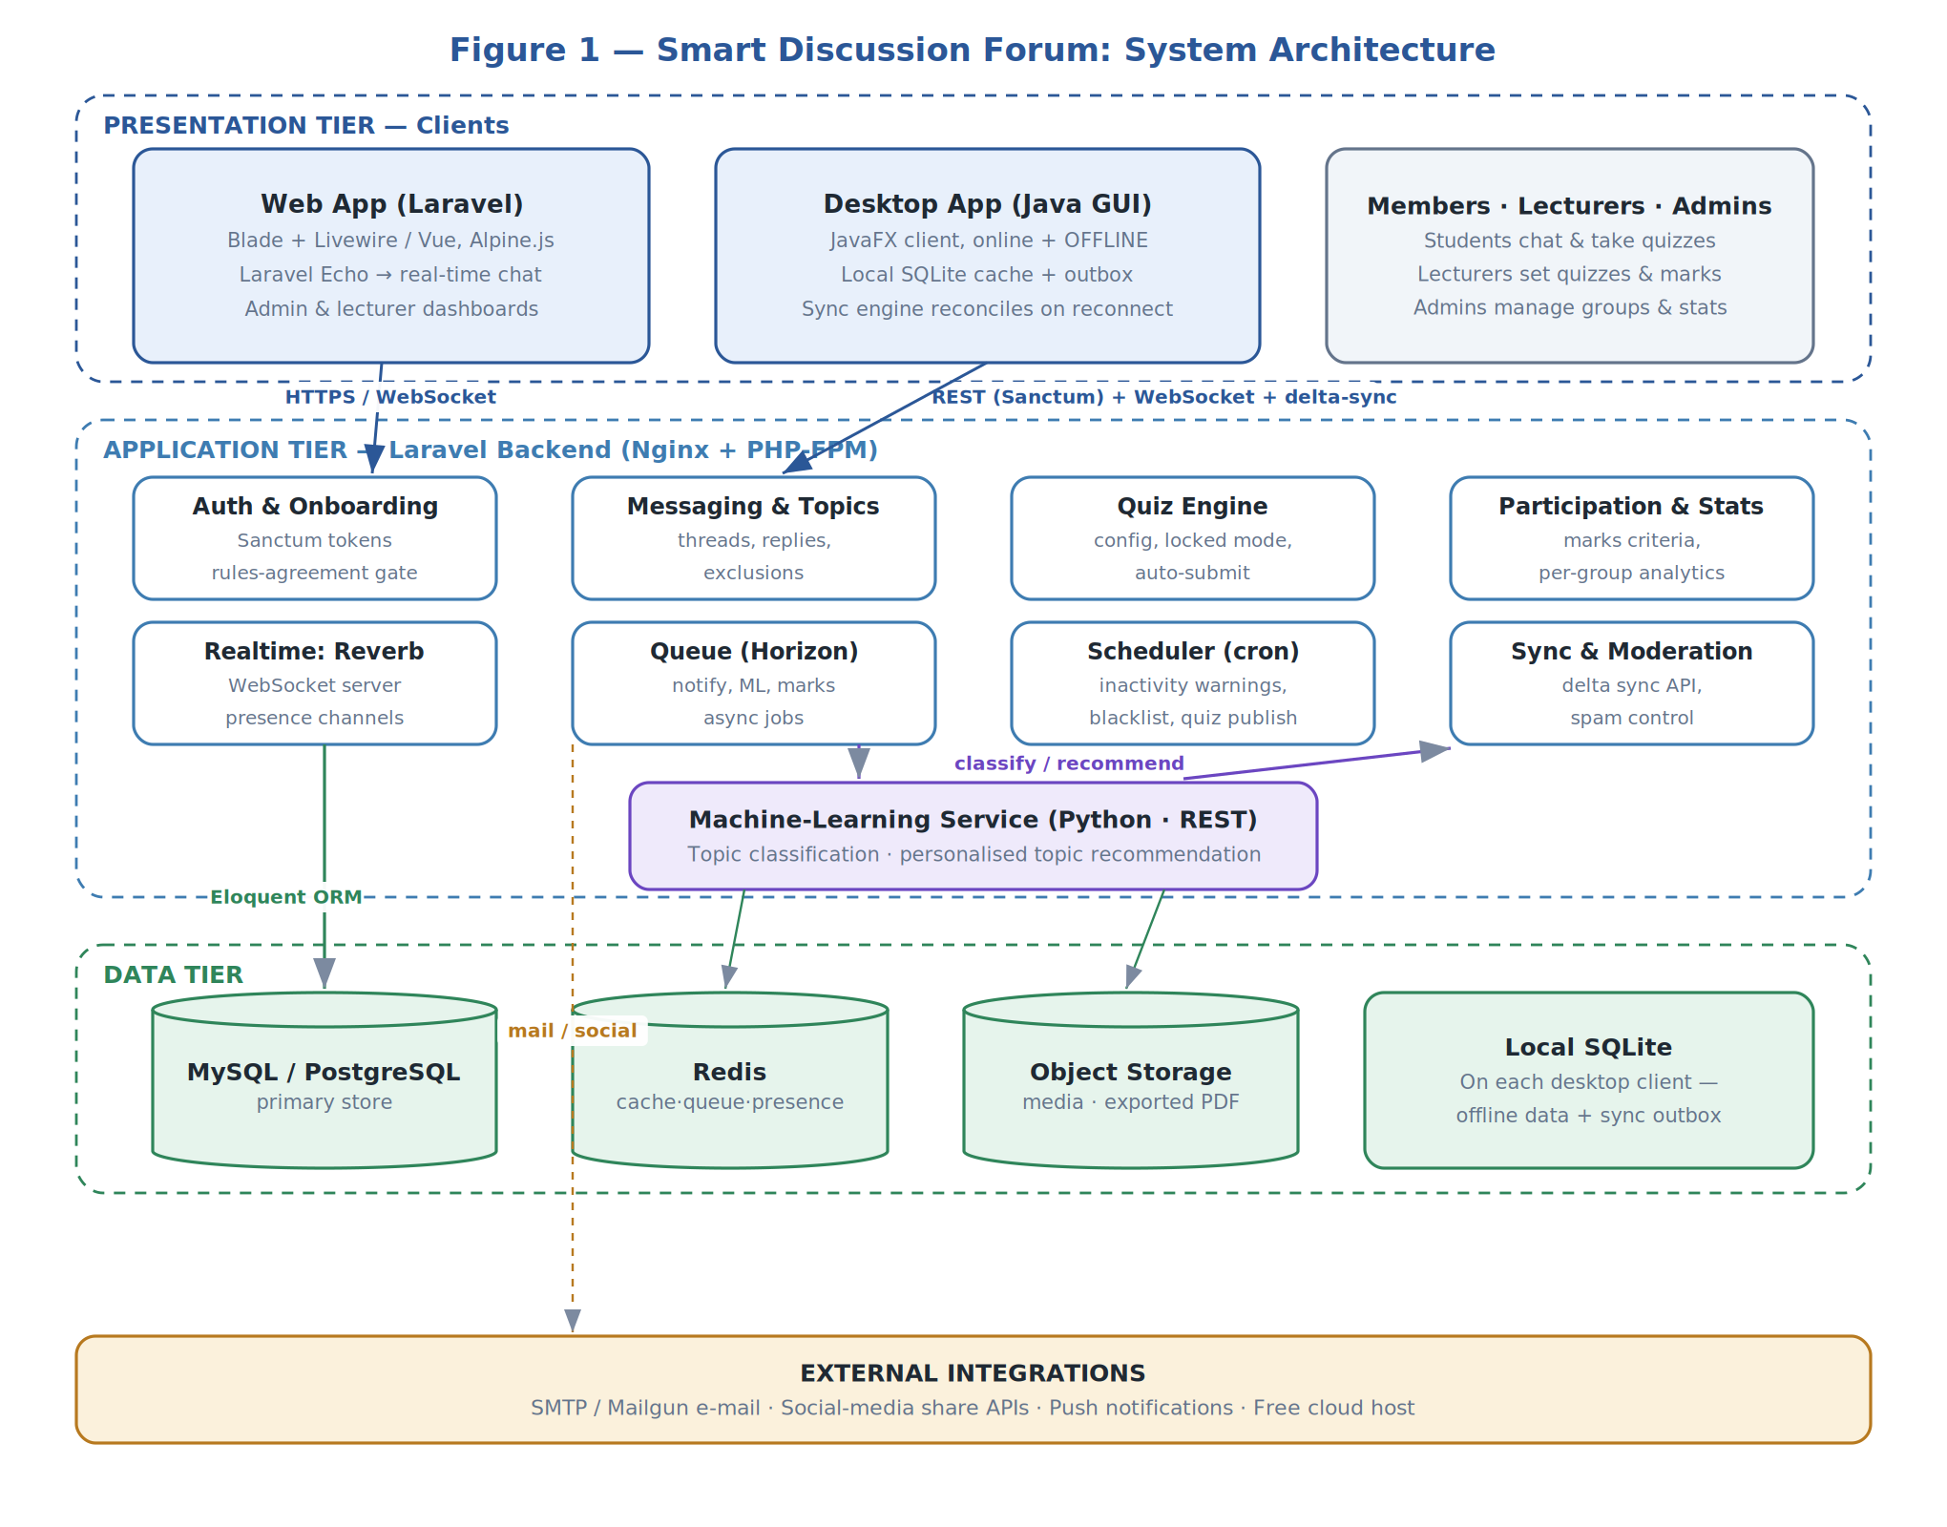
Figure 1 – Academic Pulse Forum: System Architecture

Architectural design
- Client–server, three-tier: thin web and desktop clients communicate with a central Laravel application over HTTPS and WebSocket.
- Service-oriented ML: topic classification and recommendation run in an isolated Python microservice called over REST, keeping heavy ML dependencies out of the PHP runtime.
- Offline-first desktop: the Java client owns a local SQLite store and an outbox so it remains usable without connectivity and reconciles through a delta-sync endpoint.
- Event-driven back end: queued jobs (Horizon) and scheduled tasks (cron) handle notifications, ML calls, marks computation, inactivity escalation and quiz publishing asynchronously.

Deployment and hosting operations
The application server (Nginx + PHP-FPM running Laravel, with Reverb, Horizon workers and the scheduler) is deployed to a free-tier cloud host. Managed/companion services provide the database, Redis and object storage, and the ML service runs as a separate process. Java desktop clients are distributed to members' machines and hold a local SQLite store.
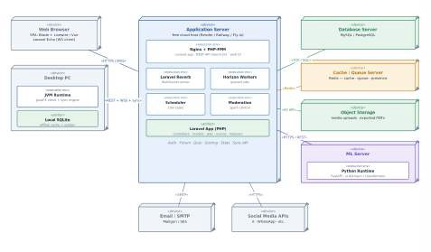
Figure 2 - Deployment diagram

A free tier (e.g., Render, Railway or Fly.io) satisfies the bonus-marks hosting requirement; because the API is stateless and the queue/cache are externalised, the app fits a single small instance.
Environments: local development, and a single hosted production/demo environment for the supervisor presentation.

Security
      - Authentication: Laravel Sanctum bearer tokens for the desktop and SPA; passwords stored with a strong one-way hash.
      - Authorization: role-based access control (member, student, lecturer, administrator) enforced server-side on every endpoint and broadcast channel.
      - Selective messaging: recipient exclusions are applied server-side before persistence and broadcast, so excluded users never receive the data.
      - Transport security: HTTPS for REST and WSS for WebSocket traffic.
      - Input validation & moderation: server-side validation, rate limiting and spam/flood controls mitigate irrelevant-content flooding (FR-1).
      - Quiz integrity: server-authoritative timing and locked attempts reduce cheating; answers are auto-graded from stored options.

      - Auditing: warnings, blacklisting and reinstatement are recorded with timestamps for accountability.

API design specifications
All endpoints are authenticated with a Sanctum bearer token unless noted. Responses are JSON. The sync endpoint is the cornerstone of offline support.

Method & path | Purpose
POST /api/register | Onboard a new member after rules agreement (returns token).
POST /api/login | Authenticate and issue an API token.
GET /api/groups/{id}/topics | List topics in a group (with ML labels).
GET /api/topics/{id}/messages | Fetch a topic and all its responses.
POST /api/messages | Post a message/reply; body may include excluded_user_ids.
POST /api/sync | Upload the outbox and pull new messages since a watermark (delta sync).
GET /api/topics/{id}/export | Export a topic and its responses to PDF.
POST /api/posts/{id}/share | Forward a post to a chosen social-media platform.
POST /api/quizzes | Create/configure a quiz (lecturer).
GET /api/quizzes/{id}/attempt | Open an attempt (enforces start time and lock).
POST /api/attempts/{id}/submit | Submit answers (also called by auto-submit).
GET /api/quizzes/{id}/report | Retrieve the performance report (all members).
GET /api/groups/{id}/statistics | Per-group statistics (administrator).

Decomposition description
Table 3 - API paths

Context diagram (DFD level 0)
The context diagram shows the system as a single process exchanging data with its external entities: the human actors, the e-mail/push service, social-media platforms and the ML service.

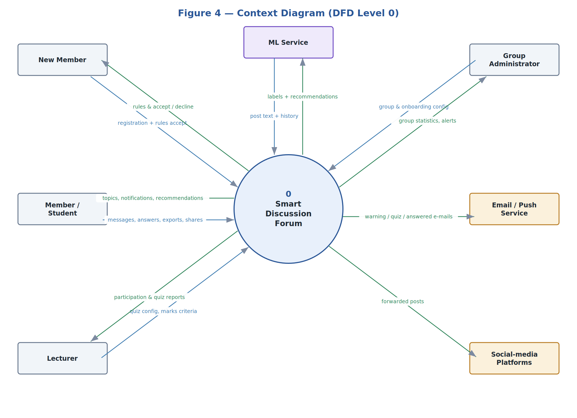

Figure 3 - Context diagram (DFD level 0)

Level - 1 Data flow diagram
The level-1 DFD decomposes the system into four processes — Accounts & Onboarding, Discussion & Messaging, Activity & Enforcement, and Quiz/Scoring/Statistics — over four data stores, with outward flows to the e-mail, social-media and ML services.
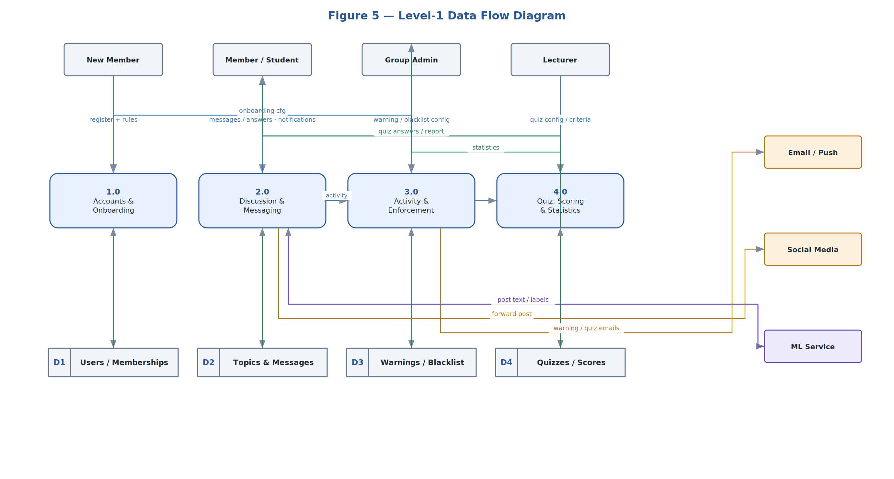
Figure 4 - Level 1 DFD

Sequence – online/offline messaging and sync
Offline, the desktop client queues messages to a local outbox and renders them optimistically. On reconnect it calls the sync endpoint, which deduplicates by client UUID, applies recipient exclusions, requests ML classification, returns acknowledgements and newly-arrived messages, and broadcasts the message in real time to all other clients.
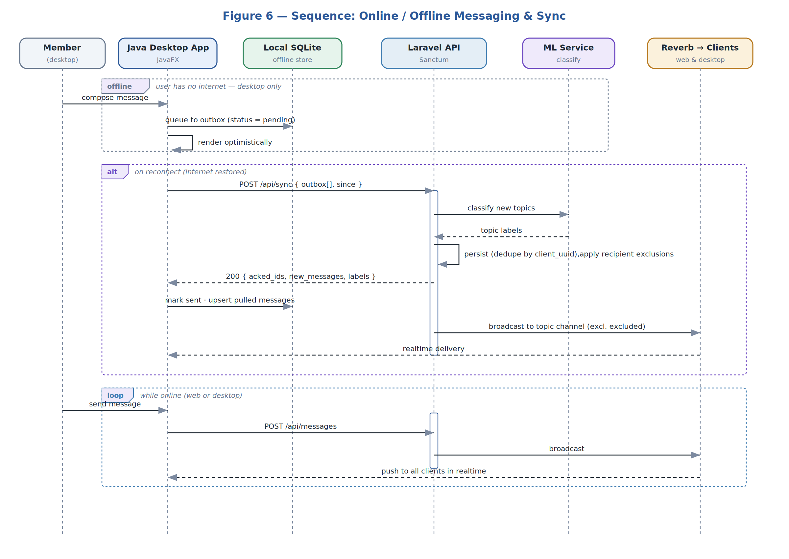
Figure 5 - Sequence diagram (Online/Offline message sync)

Sequence – quiz lifecycle
A lecturer configures the quiz ahead of time; the configuration is broadcast as an announcement. At the start time the scheduler publishes the quiz, clients open it in a locked (kiosk) mode, answers autosave, and the attempt is submitted on the member's action or automatically on expiry. After the quiz ends, all members can view the performance report.
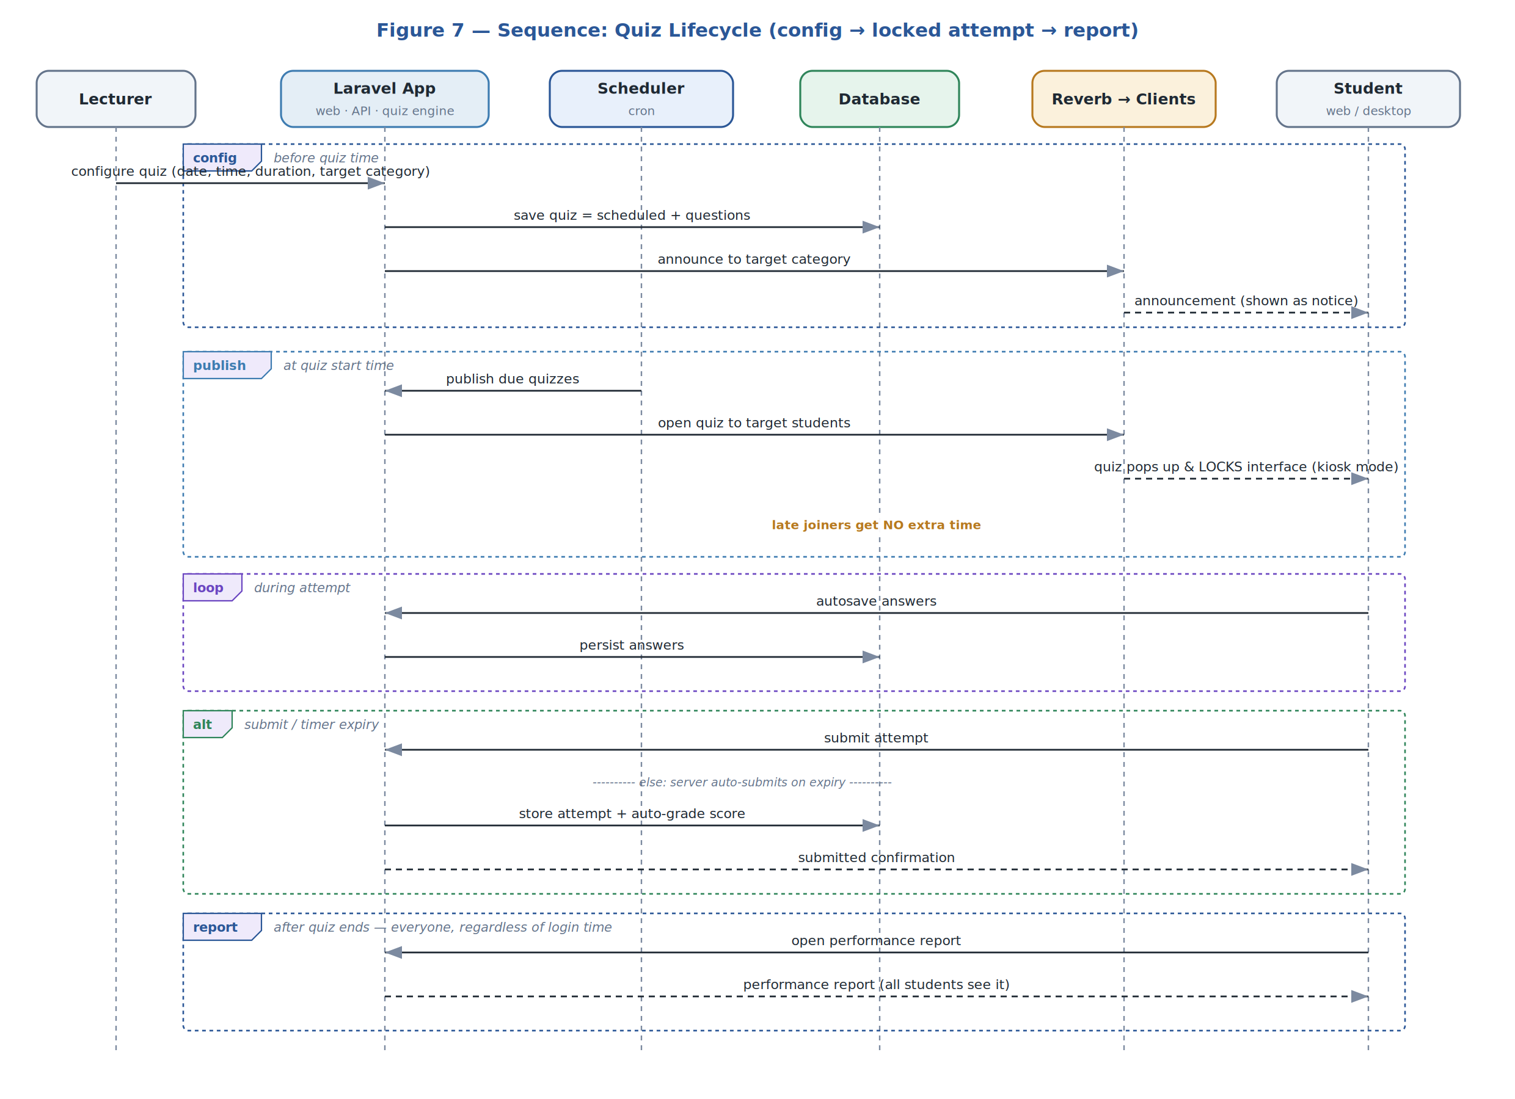
Figure 6 - Sequence diagram (Quiz lifecycle)

Activity – inactivity, warnings and auto-blacklist
A scheduled job examines each member's last-active time against an administrator-configured limit. Inactive members receive up to two warnings with a grace timer; failure to comply triggers an automatic, time-boxed blacklist that is lifted on expiry.
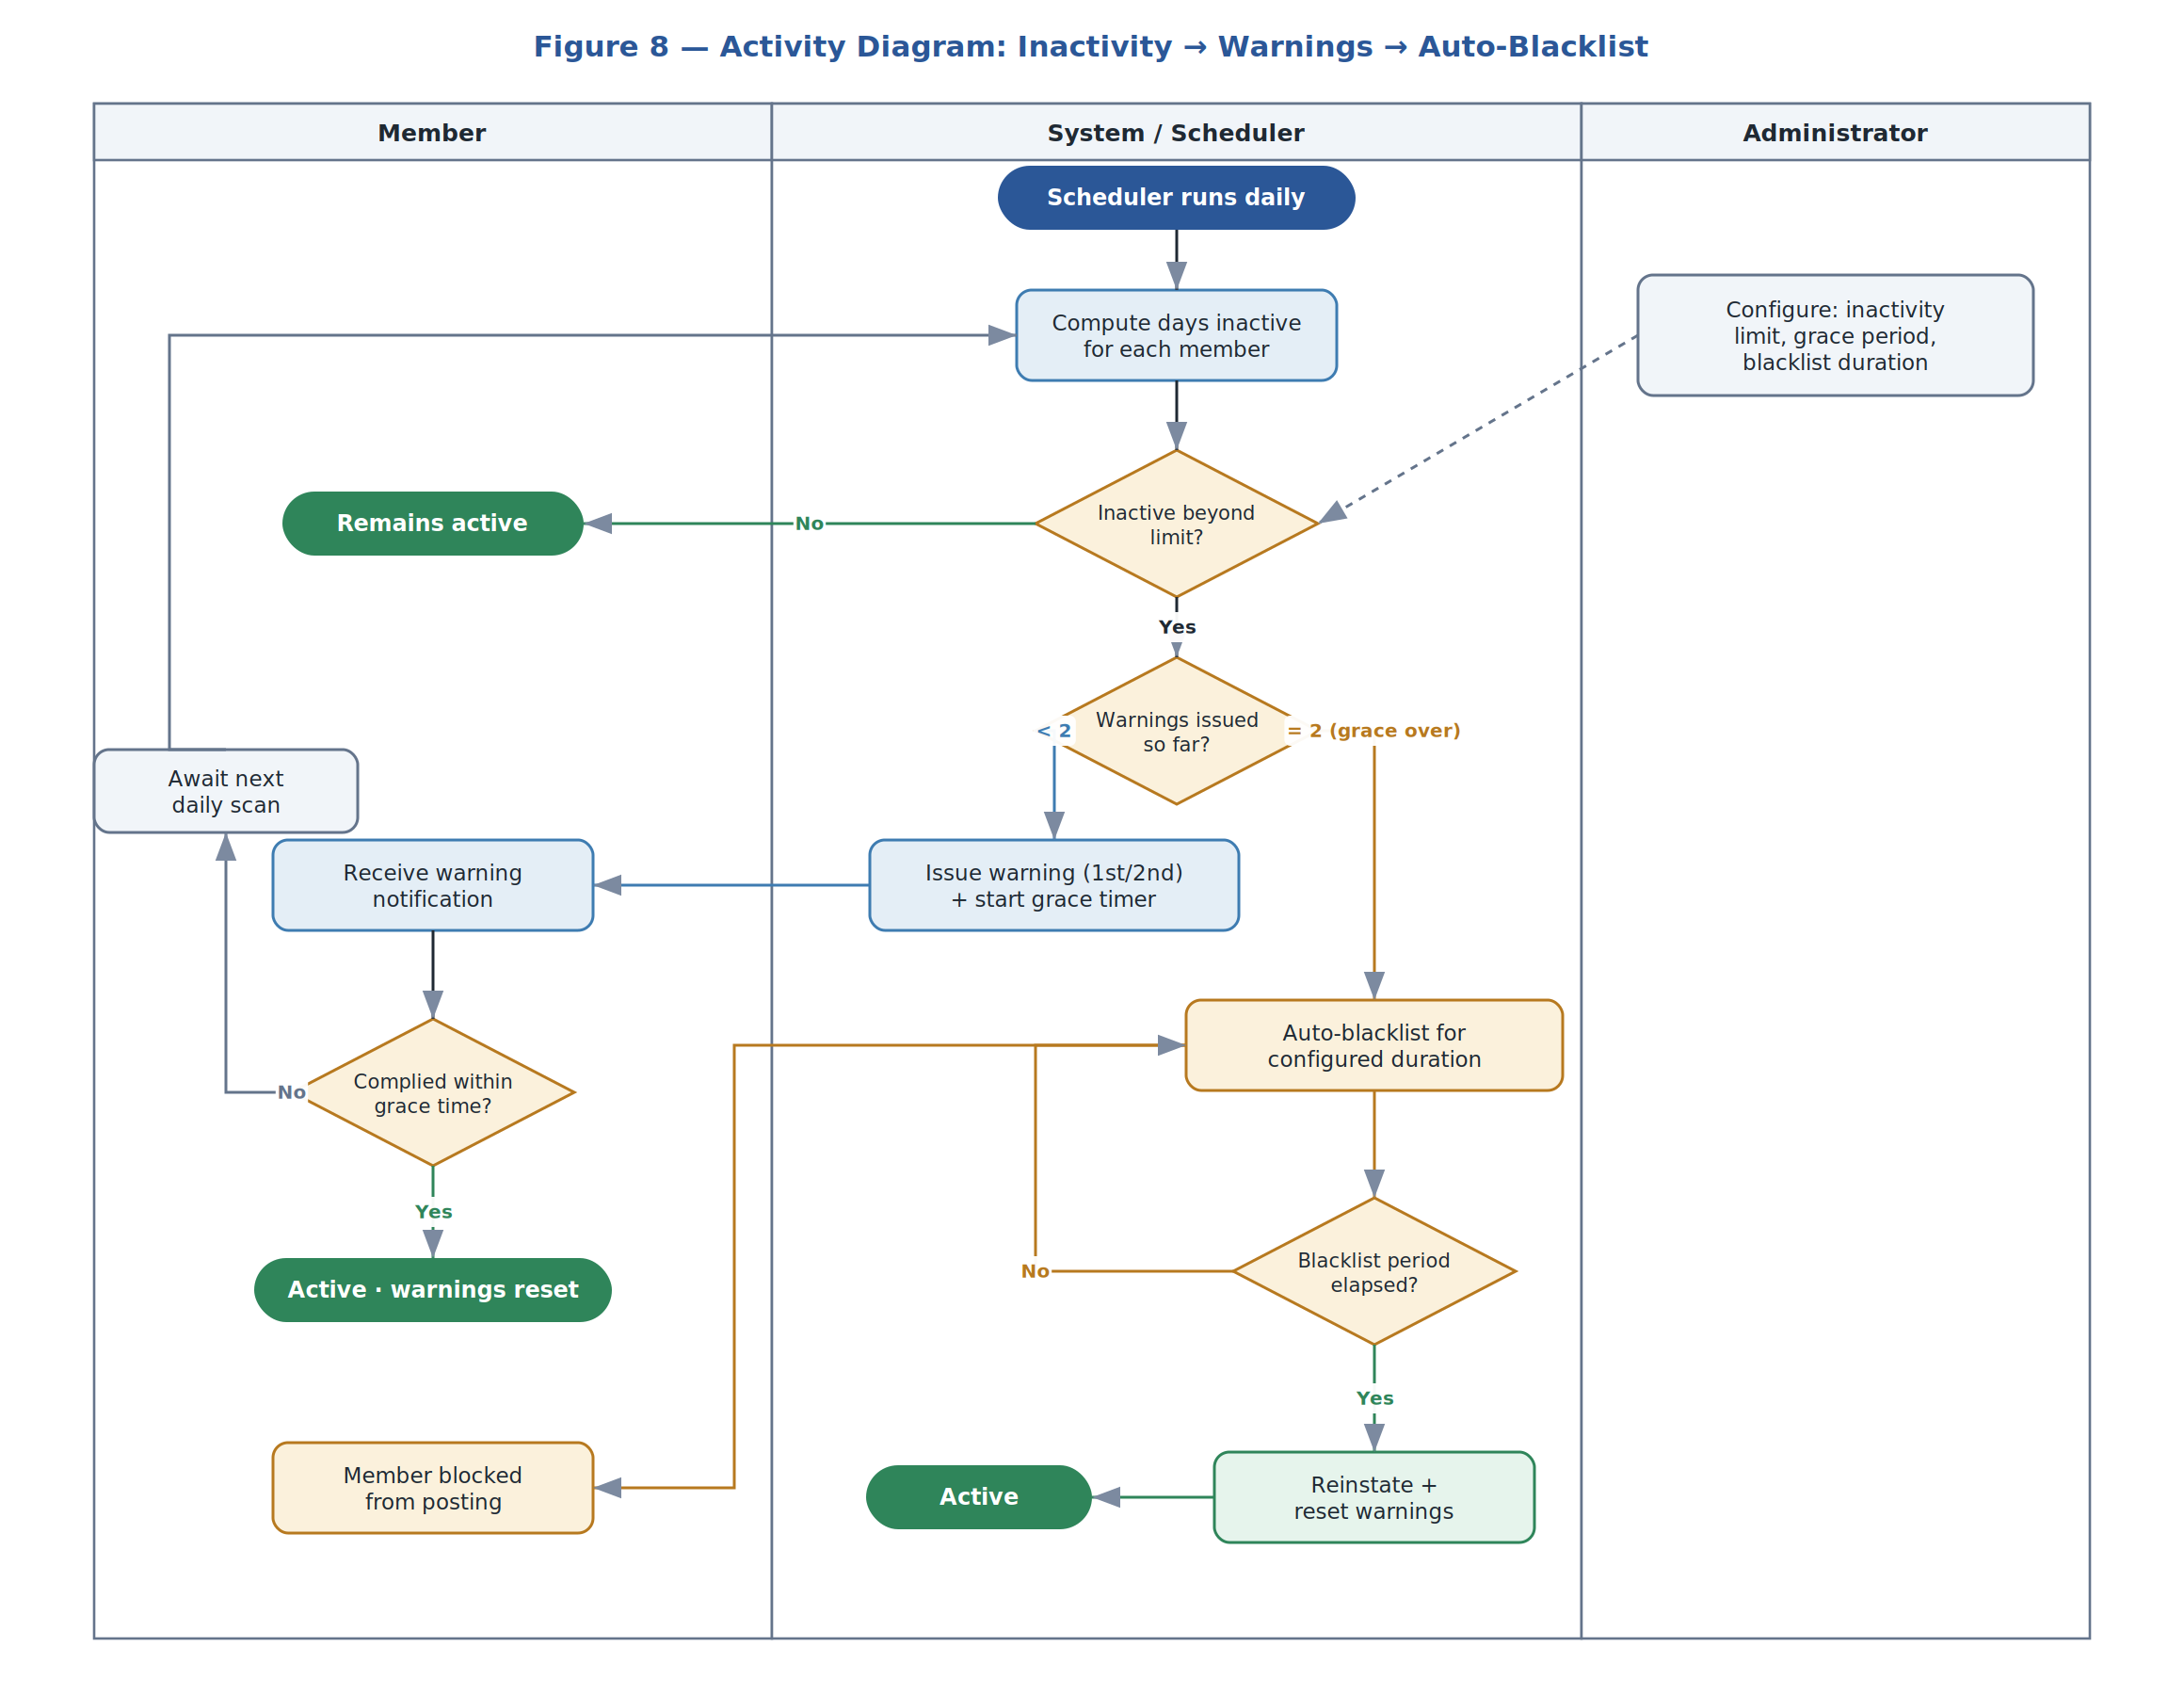
Figure 7 - Activity diagram

Class diagram
The domain model maps onto Laravel Eloquent models, supported by a small number of service classes. The diagram shows the principal attributes, key methods, associations and multiplicities, and the service dependencies for synchronization, machine learning and moderation.
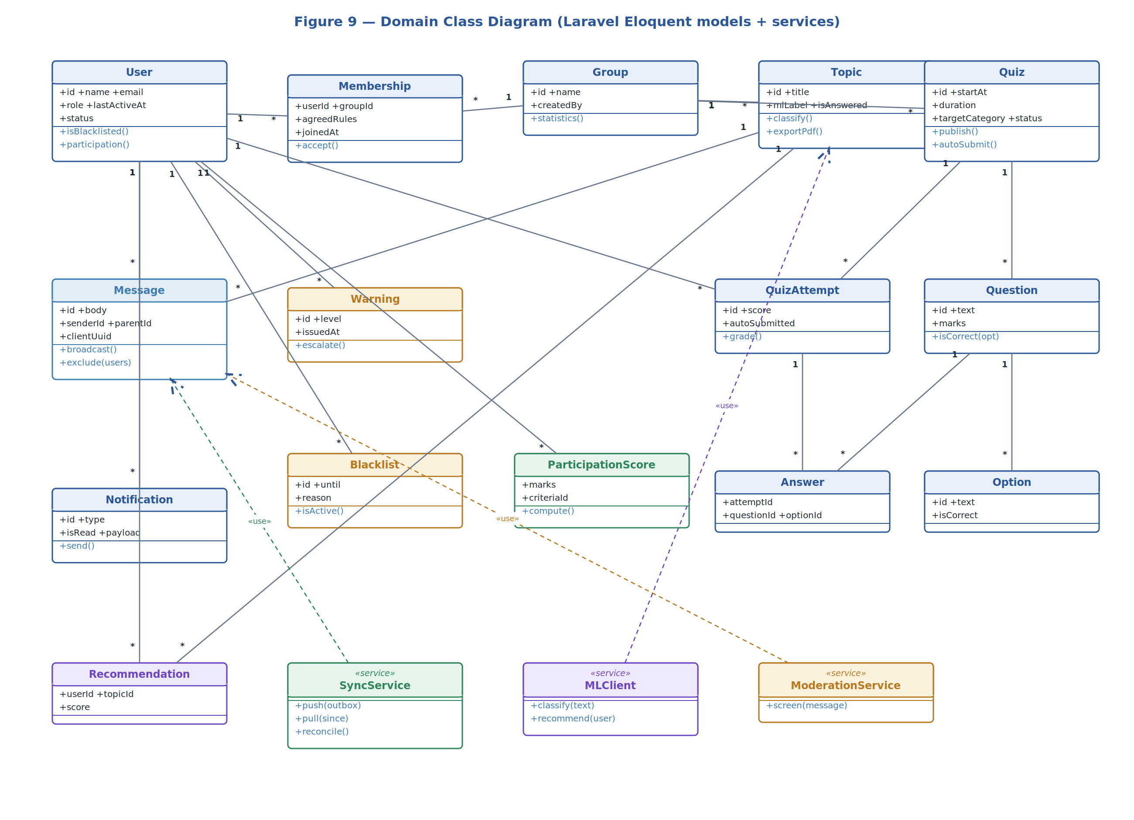
Figure 8 - Class diagram

Use case model
This is an object oriented design that show cases the actors and their responsibilities

Actor | Responsibilities
New Member | Reads the platform rules and accepts or declines them during onboarding.
Member / Student | Posts and reads messages, excludes recipients, exports topics, chats in real time, takes quizzes, receives recommendations.
Lecturer | Configures and publishes quizzes, sets participation criteria, awards marks.
Group Administrator | Manages members and groups, configures onboarding rules and enforcement thresholds, views statistics.
System (ML + Scheduler) | Classifies and recommends topics, issues warnings, auto-blacklists, and notifies the asker when answered.
Table 4 - Use case actors & responsibilities
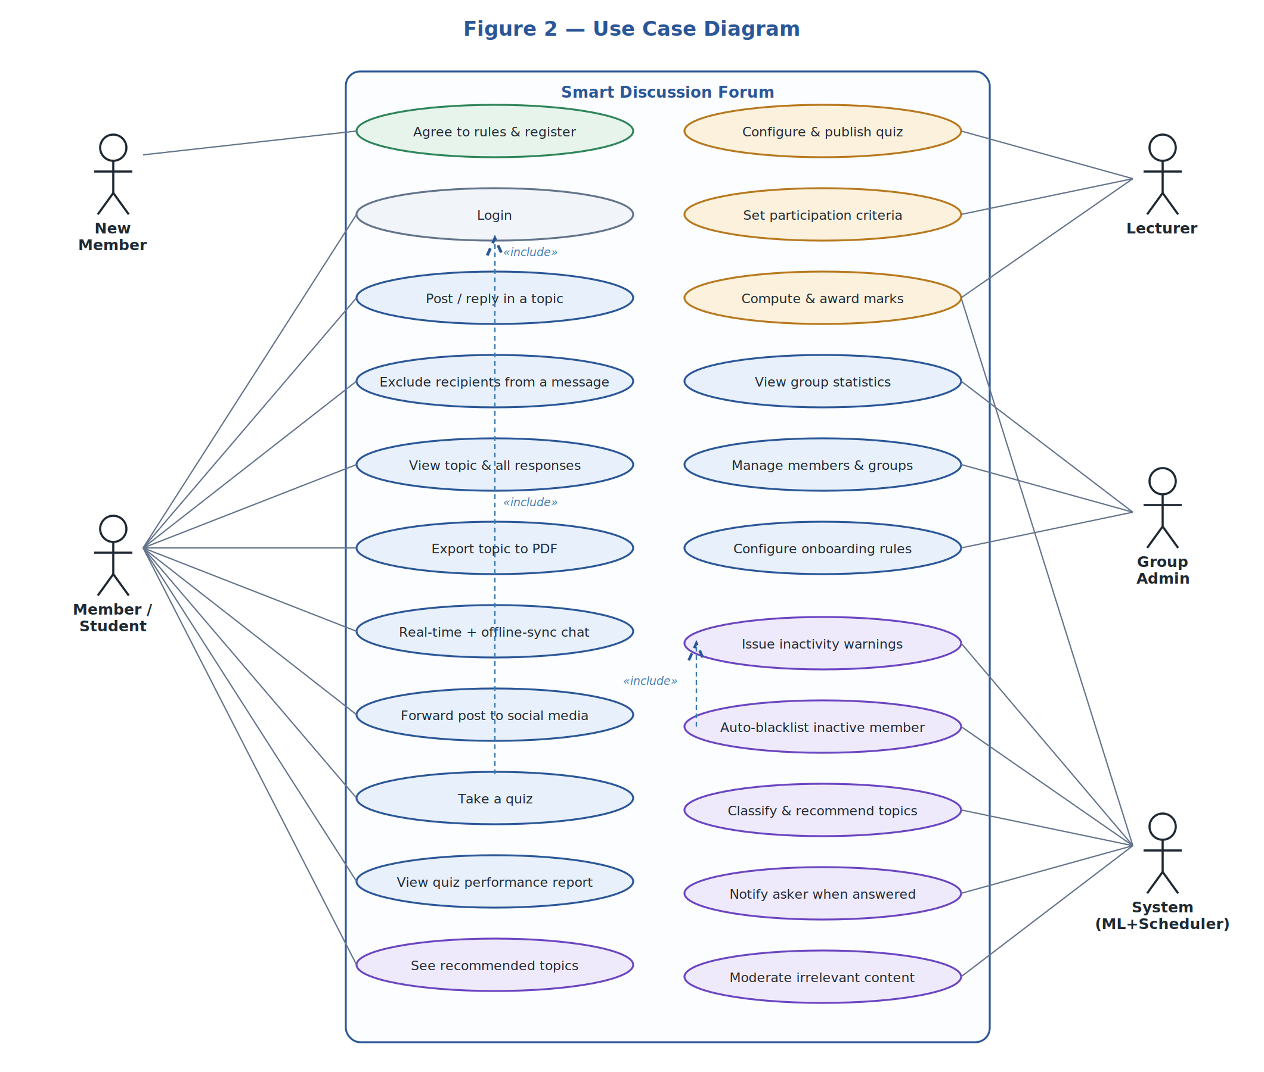

Figure 9 - Use case diagram

Design rationale
The selected architecture was chosen for the following reasons:
- Scalability: The three-tier architecture allows the system to accommodate increasing numbers of users, discussions, and quizzes without major redesign.

- Maintainability: Separating presentation, business logic, and database layers makes the system easier to update and maintain.

- Performance: Business logic processing occurs on the server, reducing the workload on client devices and improving system responsiveness.

- Reliability: The synchronization module ensures users can continue accessing saved information when offline and receive updates once internet connectivity is restored.

- Security: Authentication, authorization, and role management mechanisms protect user data and system resources.

- Flexibility: The architecture supports both: Web-based access through Laravel and Desktop access through Java GUI allowing users to interact with the platform using their preferred interface.

- Intelligence: The integration of Machine Learning enables:
  - Automatic topic classification
  - Recommendation of relevant discussions
  - Improved user engagement

DATA DESIGN

Data description
The conceptual data model is shown below. Primary keys are underlined and foreign keys are tagged FK; full column lists are given in the data dictionary that follows.
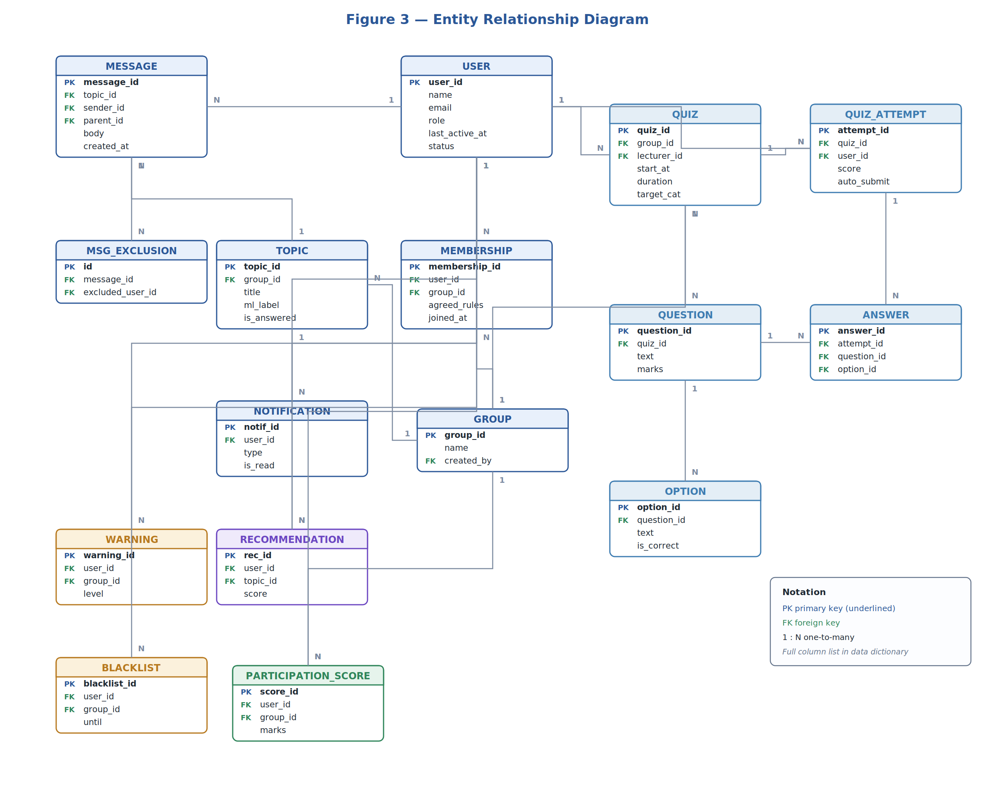

Figure 10 - Entity Relationship Diagram (ERD)

Data dictionary
USER
Column | Type | Notes
user_id | BIGINT PK | Identity
name | VARCHAR | Display name
email | VARCHAR UNIQUE | Used for notifications/recovery
password | VARCHAR | Hashed (bcrypt/argon2)

Column | Type | Notes
role | ENUM | member · student · lecturer · admin
last_active_at | TIMESTAMP | Drives inactivity detection
status | ENUM | active · blacklisted · declined

MESSAGE
Table 5 - User table

Column | Type | Notes
message_id | BIGINT PK | Identity
topic_id | BIGINT FK | Parent topic
sender_id | BIGINT FK | Author (USER)
parent_id | BIGINT FK NULL | Reply target (self-reference)
body | TEXT | Message content
client_uuid | CHAR(36) | Idempotency key for offline sync
created_at | TIMESTAMP | Server receive time
Table 6 - Message table

MSG_EXCLUSION (selective messaging)
Column | Type | Notes
id | BIGINT PK | Identity
message_id | BIGINT FK | Excluded for this message
excluded_user_id | BIGINT FK | Recipient who must not receive it
Table 7 - Message Exclusion table

WARNING / BLACKLIST (enforcement)
Column | Type | Notes
warning_id / blacklist_id | BIGINT PK | Identity
user_id, group_id | BIGINT FK | Subject and group
level (WARNING) | TINYINT | 1 or 2
until (BLACKLIST) | TIMESTAMP | End of configured suspension
issued_at / reason | TIMESTAMP / VARCHAR | Audit fields
Table 8 - Warning & Blacklist table

QUIZ / QUESTION / OPTION / QUIZ_ATTEMPT / ANSWER (assessment)
Table | Key columns
QUIZ | quiz_id PK · group_id FK · lecturer_id FK · start_at · duration · target_category · status
QUESTION | question_id PK · quiz_id FK · text · marks
OPTION | option_id PK · question_id FK · text · is_correct
QUIZ_ATTEMPT | attempt_id PK · quiz_id FK · user_id FK · score · auto_submitted · started_at · submitted_at
ANSWER | answer_id PK · attempt_id FK · question_id FK · option_id FK
Table 9 - Quiz table

Supporting tables not expanded here include MEMBERSHIP (agreed_rules, joined_at), TOPIC (ml_label, is_answered),
PARTICIPATION_CRITERIA / PARTICIPATION_SCORE, NOTIFICATION,
RECOMMENDATION, SOCIAL_SHARE, and SYNC_OUTBOX (client_uuid, payload, status) used by the desktop client.
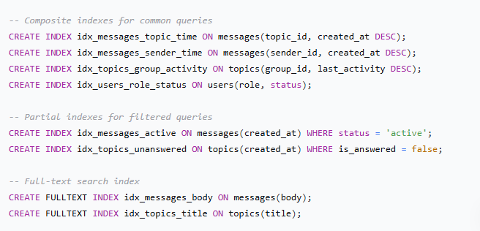
Figure 11 - For Indexing strategy

COMPONENT DESIGN

Offline Synchronization Design
The desktop client is offline-first. Every locally-composed message is written to a SYNC_OUTBOX row with a client-generated UUID and shown immediately. When connectivity returns, the client performs a delta sync:
- Push: upload all pending outbox items together with the timestamp/watermark of the last successful sync.
- Server reconcile: persist each item, deduplicating on client_uuid so a retried sync never creates duplicates; apply recipient exclusions; request ML classification for new topics.
- Pull: the server returns acknowledged item IDs plus all messages created since the watermark that the member is permitted to see.
- Apply & broadcast: the client marks outbox items as sent and upserts pulled messages; the server broadcasts new messages in real time to other online clients.
Because writes are idempotent and the watermark advances only after a successful pull, the protocol is safe to retry and resumes cleanly after interruption. Conflicts are avoided by treating messages as immutable, append-only records; edits and deletions are modelled as new events rather than in-place mutations.

Quiz and Proctoring Design
Quizzes are configured ahead of time and enforced by the server so that timing is fair and tamper-resistant.
- Pre-configuration: the lecturer sets the date, time, duration and target student category before the quiz time; the configuration is published to that category as an announcement.
- Scheduled publishing: at the start time the scheduler flips the quiz to be published and broadcasts an open event to the targeted students.
- Locked attempt (kiosk): when the interface is open at quiz time the quiz pops up and locks the client, preventing other actions until the attempt ends.
- Server-authoritative timing: the deadline is computed on the server from start time plus duration; answers autosave continuously.
- Auto-submit & no extra time: if the timer expires before submission the attempt auto- submits; members who join late receive no additional time.
- Reporting: after the quiz ends, every member — regardless of when they log in — can view the performance report; objective questions are auto-graded.

Machine learning
Two ML capabilities are provided by a Python microservice that the Laravel backend calls over REST, keeping model dependencies isolated from the web runtime.
- Topic Classification
New topics and messages are sent (asynchronously, via a queued job) to the ML service, which returns a category label stored on the TOPIC record. Classification helps organise the forum and supports moderation of irrelevant material (FR-1). A text classifier (TF-IDF with a linear model as a baseline, upgradeable to a transformer encoder) is trained on labelled historical topics.
- Topic Recommendation
Recommendations are generated from each member's past engagement — the topics they have read, posted in, and reacted to. A content-based approach ranks unseen topics by similarity to the member's engagement profile; results are written to the RECOMMENDATION table and surfaced in the client (FR-11). The design allows the recommender to be retrained periodically as engagement data accumulates
Operational Notes:
Inference is invoked from queued jobs so user-facing requests are never blocked.
The service is stateless; models are loaded at start-up and can be versioned independently of the web app.
If the ML service is unavailable, topics remain usable with a default/unclassified label and recommendations fall back to most-recent/most-active topics.

HUMAN INTERFACE DESIGN

Overview of user interface
Users access the forum via web or a desktop app interface. When they open the system for the first time, a validation modal prompts new users to accept application rules. The main dashboard filters communication feeds by individual topic threads making it easy for users to find and follow conversations. When a quiz begins, a pop up sub-window enters full screen lockout mode, capturing focused responses and blocking external actions until submittal or timer.

Screen images
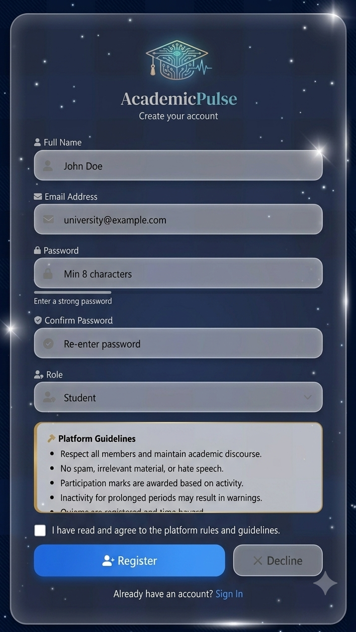

Figure 12 – Registration page

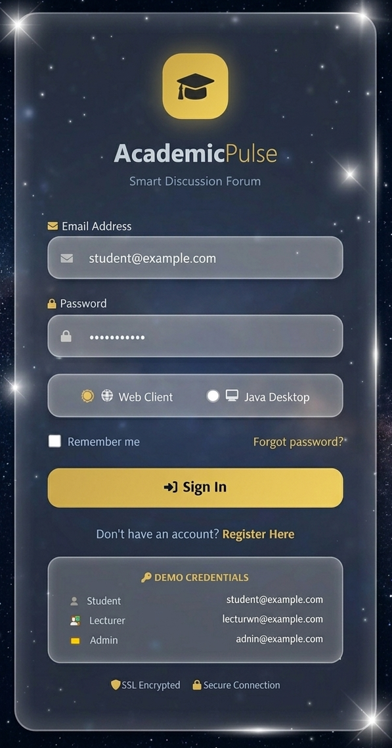

Figure 13 - Login page

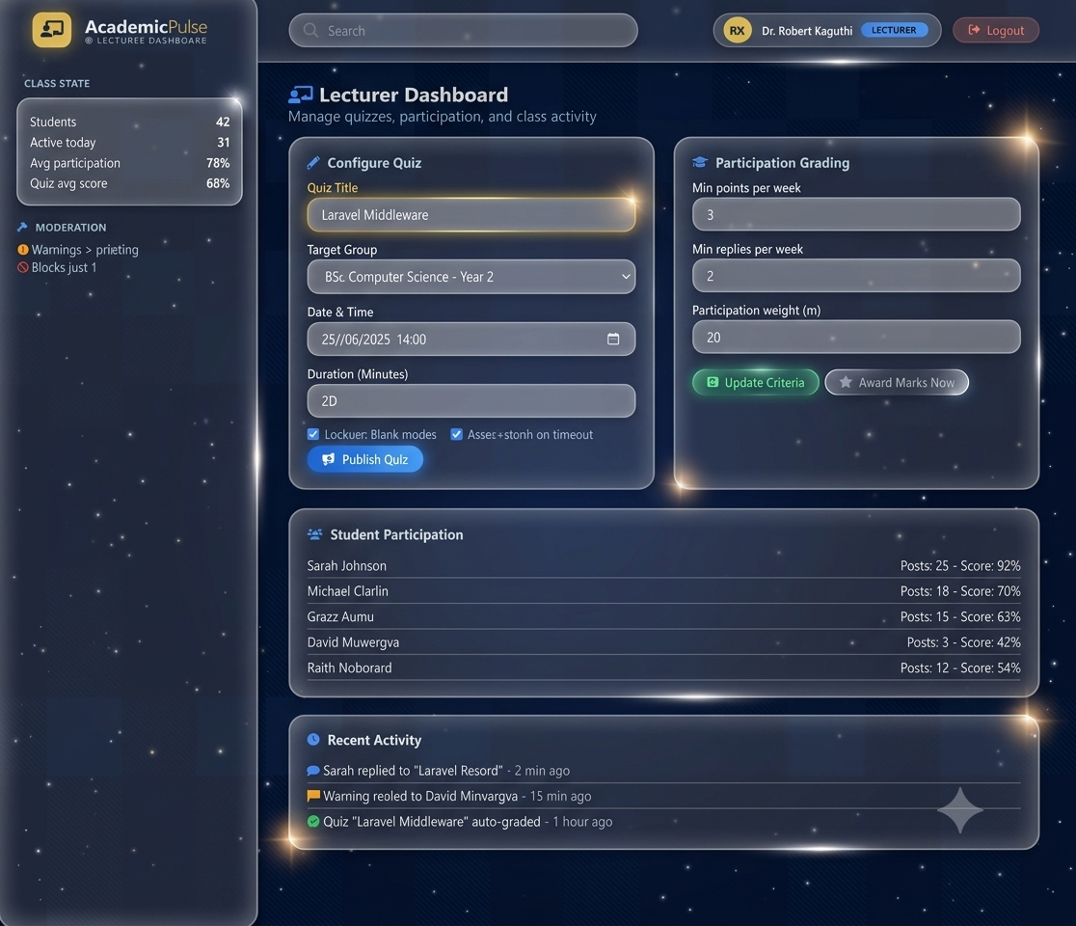

Figure 14 - Lecturer dashboard

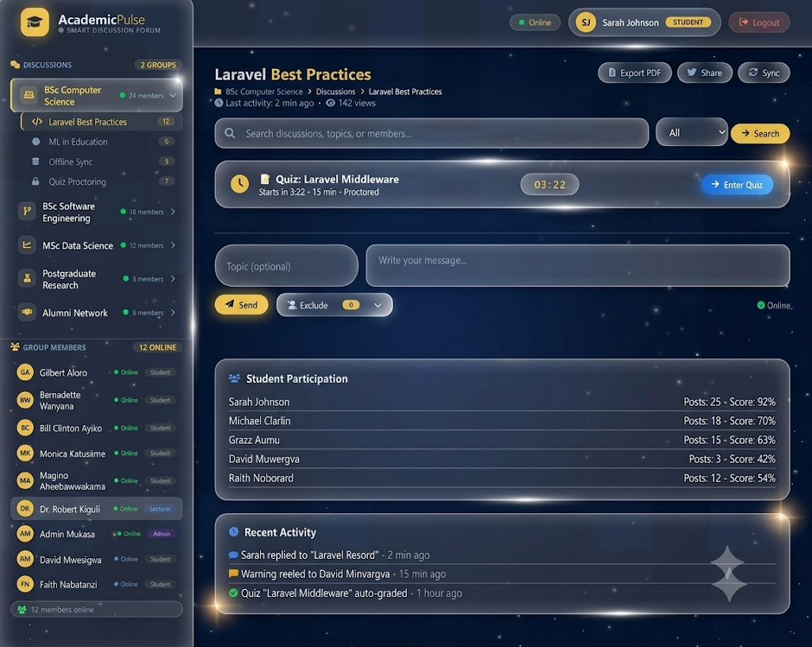

Figure 15 - Member/Student dashboard

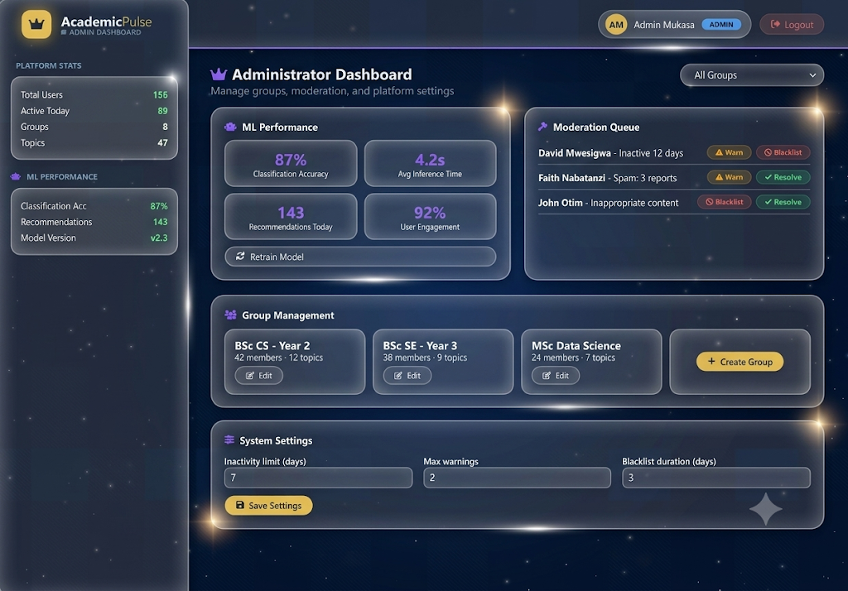

Figure 16 - Admin dashboard

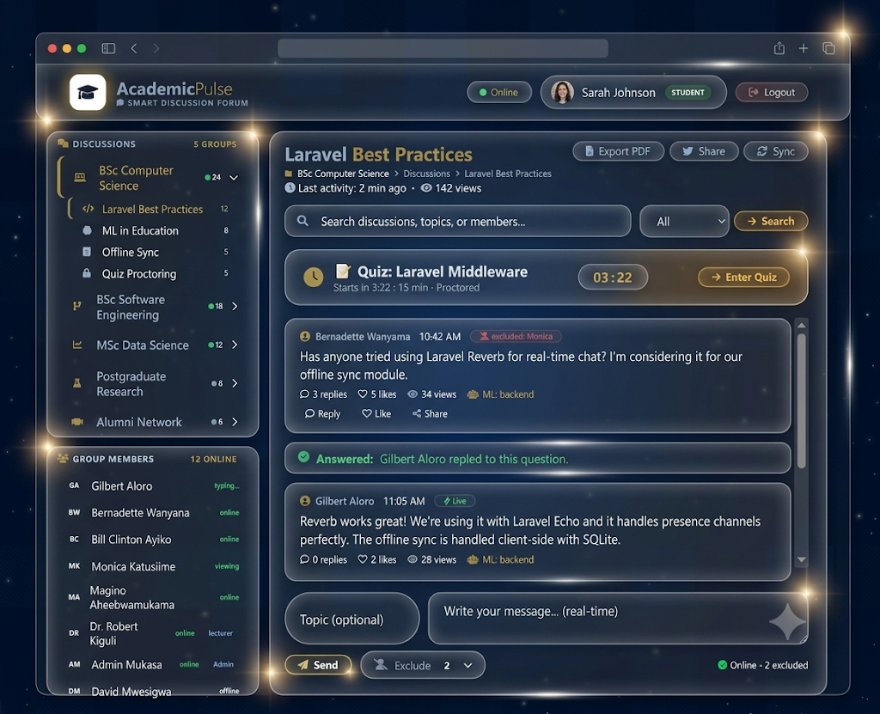

Figure 17 - Mockup screen

Screen objects and actions
- Email Address Input Field: A text box where users enter their university or registered system email address to identify their account.
- Password Input Field: A secure input field that hides typed characters to protect the user’s password and account information.
- Interface Mode Radio Buttons: Options that allow users to choose either Web Client Mode or Java Desktop Client Mode. When the Java Desktop Client is selected and the user is offline, the system accesses locally stored SQLite cache data.
- Sign in Button: A button that verifies the entered login credentials. If authentication is successful, the user is directed to the appropriate workspace based on their role (Student, Lecturer, or Admin).
- Register Here Link: A clickable link that takes new or unauthenticated users to the registration page to create an account.
Login page details;
- Registration Fields (Full Name, Email, Password, Confirm Password): Input fields used to collect the user’s personal and account information required for registration.
- Platform Guidelines Block: An information section that displays the platform’s rules, usage policies, participation requirements, and restrictions to guide new users.
- Rules Agreement Checkbox: A checkbox that users must select to confirm they have read and accepted the platform guidelines before proceeding.
- Register Button: A button that submits the registration details and creates a new user account once all required fields are completed and the agreement checkbox is selected.
- Decline Button: A button that cancels the registration process and returns the user to the Login screen without creating an account.
Student’s page details
- Topics List Navigation View (Left Pane): A sidebar that displays available conversation topics. Selecting a topic updates the interface to show only discussions related to that category.
- Active Thread Display Pane (Right Pane): A message area that shows conversations for the selected topic while filtering content according to system rules and permissions.
- Export Topic to PDF Button: A button that generates and downloads a PDF containing the visible conversation history of the selected topic.
- Forward to Social Media Button: A sharing option that allows users to repost selected content to supported social media platforms.
- Live Announcements Dock: A notification panel that displays upcoming assessments, including their date, time, and duration. At the scheduled start time, it expands into a full- screen quiz interface for assessment participation.

Lecturer’s page details;
- Quiz Configuration Form Fields: Input fields where instructors enter assessment details such as the title, class, date, time, and duration before publishing the quiz.
- Lockout and Auto-Submit Checkboxes: Configuration options that control quiz behavior. Lockout restricts students from leaving the quiz window, while auto-submit automatically saves and submits responses when the timer expires.
- Publish Assessment Button: A button that saves the assessment settings to the database and sends notifications to the intended student groups.
- Participation Grading Engine Metrics Selector: A control that allows instructors to define participation requirements, such as the minimum number of posts, for automated grading and evaluation.
Administrator Dashboard details;
- Select Forum Group Dropdown Menu: A dropdown list that allows administrators to switch between different discussion forums and view group-specific information and activities.
- Group Metrics & Stats Panel: A dashboard section that displays key statistics such as member count, activity levels, performance indicators, and spam-related data.
- Moderation Queue & Active Warnings Monitor: A monitoring panel that shows flagged content and user warning records. It tracks warning levels and supports automatic blacklisting of users who repeatedly violate platform rules.
- Machine Learning Performance Container: A read-only analytics section that displays performance data for automated topic classification systems and recommendation engines.

REQUIREMENTS MATRIX
The table below cross-references each functional requirement from the project brief (numbered FR1–FR12, corresponding to requirements 1–12 in the SRS) against the system components from Sections 4 and 5 that satisfy it.

Code | Functional Requirement | Satisfied By (Component)
FR1 | Prevent members from flooding the  forum with irrelevant material | Topic, Post.createPost(), classifyTopic()
FR2 | Keep unanswered questions visible to  the asker despite high post volume | Post, Topic.viewTopic()
FR3 | Allow members to exclude specific  people from their communications | Exclusion, Member.excludeMember()
FR4 | Issue 2 warnings for prolonged inactivity; auto-blacklist on non-  compliance | Warning,Blacklist, Member.checkInactivity(),  Notification.send()
FR5 | Show new members the platform  rules; register if agreed, decline if not | Registration, Member.register()
FR6 | Filter/view all chats for a specific  topic; export to PDF | Topic.viewTopic(), Topic.exportToPDF()
FR7 | Provide administrators with group-  specific statistics | Statistic,  Administrator.viewGroupStatistics()
FR8 | Support web/desktop real-time chat;  offline access with sync on reconnect | Post, OfflineCache, Member.goOffline(),  Member.syncOnReconnect()
FR9 | Award participation marks based on  lecturer-defined criteria | Lecturer.setParticipationCriteria(),  Lecturer.awardParticipationMarks(), Statistic
FR10 | Configure, launch, auto-submit, and report on timed quizzes | Quiz, QuizConfiguration, QuizAttempt, PerformanceReport, Lecturer.createQuiz(), Lecturer.configureQuiz(), Quiz.launchQuiz(), QuizAttempt.submitAttempt(), QuizAttempt.autoSubmitOnTimeout(),  Quiz.releasePerformanceReport()
FR11 | Use ML to classify topics and recommend topics based on  engagement | classifyTopic(), recommendTopics()
FR12 | Forward a post to a social media  platform of choice | SocialMediaShare, Member.sharePost()
Table 10 - Functional requirements

